**Facility Level**

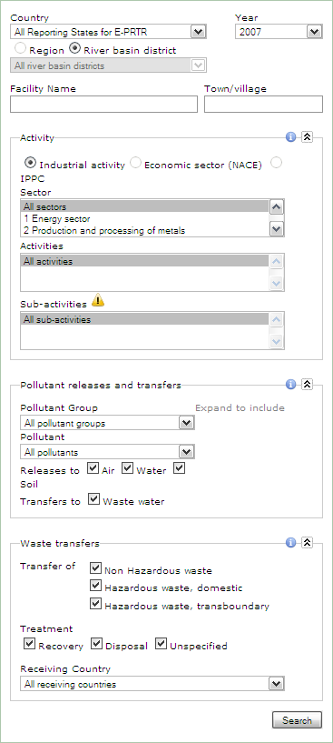

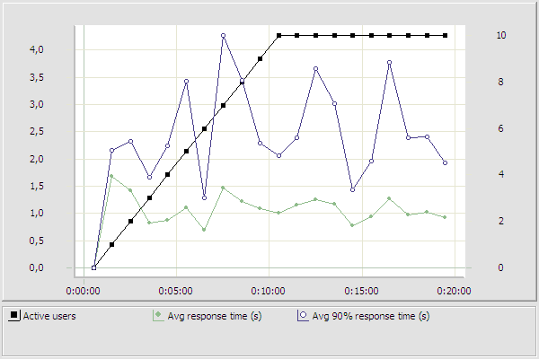

**Response time, sec**

|  |  |  |  |  |  |  |  |  |  |  |  |  |  |  |  |  |  |  |  |  |
| --- | --- | --- | --- | --- | --- | --- | --- | --- | --- | --- | --- | --- | --- | --- | --- | --- | --- | --- | --- | --- |
| Users | 0 | 1 | 2 | 3 | 4 | 5 | 6 | 7 | 8 | 9 | 10 | 10 | 10 | 10 | 10 | 10 | 10 | 10 | 10 | 10 |
| Avg | 0 | 1,69 | 1,42 | 0,82 | 0,87 | 1,1 | 0,69 | 1,47 | 1,22 | 1,08 | 1,01 | 1,15 | 1,26 | 1,17 | 0,78 | 0,94 | 1,27 | 0,97 | 1,02 | 0,92 |
| Avg90 | 0 | 2,16 | 2,33 | 1,66 | 2,24 | 3,43 | 1,29 | 4,27 | 3,45 | 2,29 | 2,05 | 2,39 | 3,65 | 3,02 | 1,44 | 1,95 | 3,78 | 2,38 | 2,4 | 1,94 |
| Max | 0 | 2,64 | 6,15 | 5,56 | 8,89 | 14,0 | 3,9 | 16,6 | 12,3 | 7,83 | 9,04 | 4,88 | 11,9 | 12 | 2,84 | 11,0 | 19,3 | 8,92 | 10,8 | 11,5 |

**Industrial Activity**

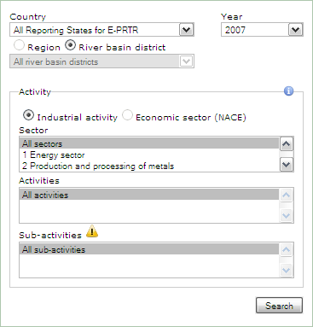

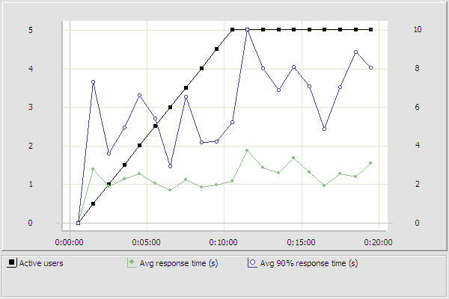

**Response time, sec**

|  |  |  |  |  |  |  |  |  |  |  |  |  |  |  |  |  |  |  |  |  |
| --- | --- | --- | --- | --- | --- | --- | --- | --- | --- | --- | --- | --- | --- | --- | --- | --- | --- | --- | --- | --- |
| Users | 0 | 1 | 2 | 3 | 4 | 5 | 6 | 7 | 8 | 9 | 10 | 10 | 10 | 10 | 10 | 10 | 10 | 10 | 10 | 10 |
| Avg | 0 | 1,39 | 0,95 | 1,15 | 1,28 | 1,03 | 0,85 | 1,12 | 0,94 | 0,98 | 1,08 | 1,88 | 1,44 | 1,31 | 1,68 | 1,32 | 0,97 | 1,27 | 1,19 | 1,56 |
| Avg90 | 0 | 3,66 | 1,8 | 2,48 | 3,31 | 2,72 | 1,46 | 3,28 | 2,1 | 2,11 | 2,62 | 5,02 | 4,01 | 3,45 | 4,05 | 3,55 | 2,43 | 3,52 | 4,44 | 4,04 |
| Max | 0 | 9,22 | 5,24 | 9,65 | 12,9 | 11,1 | 2,01 | 9,65 | 6,62 | 6,1 | 10,5 | 10,0 | 8,4 | 11,4 | 11,4 | 8,8 | 11,4 | 11,1 | 17,3 | 7,11 |

**Pollutant Releases**

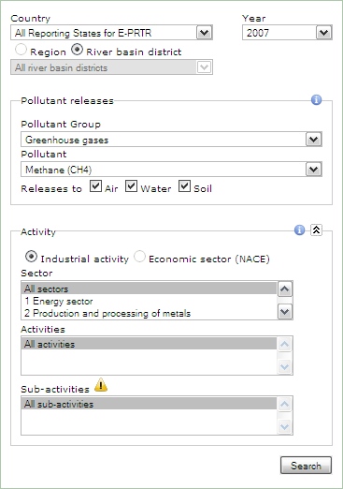

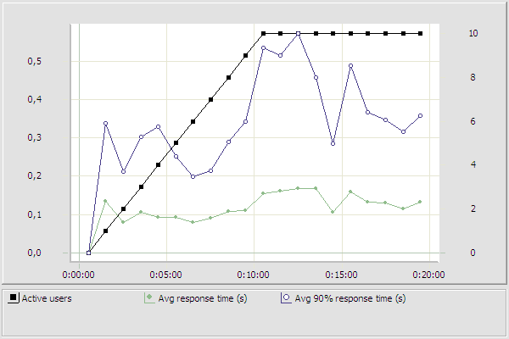

**Response time, sec**

|  |  |  |  |  |  |  |  |  |  |  |  |  |  |  |  |  |  |  |  |  |
| --- | --- | --- | --- | --- | --- | --- | --- | --- | --- | --- | --- | --- | --- | --- | --- | --- | --- | --- | --- | --- |
| Users | 0 | 1 | 2 | 3 | 4 | 5 | 6 | 7 | 8 | 9 | 10 | 10 | 10 | 10 | 10 | 10 | 10 | 10 | 10 | 10 |
| Avg | 0 | 0,14 | 0,08 | 0,11 | 0,09 | 0,09 | 0,08 | 0,09 | 0,11 | 0,11 | 0,15 | 0,16 | 0,17 | 0,17 | 0,11 | 0,16 | 0,13 | 0,13 | 0,12 | 0,13 |
| Avg90 | 0 | 0,34 | 0,21 | 0,3 | 0,33 | 0,25 | 0,2 | 0,22 | 0,29 | 0,34 | 0,53 | 0,51 | 0,57 | 0,46 | 0,29 | 0,49 | 0,37 | 0,35 | 0,31 | 0,36 |
| Max | 0 | 0,85 | 1,1 | 1,24 | 2,27 | 1,2 | 0,96 | 1,01 | 1,06 | 2,1 | 3,28 | 2,89 | 2,81 | 1,22 | 1,21 | 2,47 | 1,19 | 1,26 | 1,26 | 1,36 |

**Pollutant Transfers**

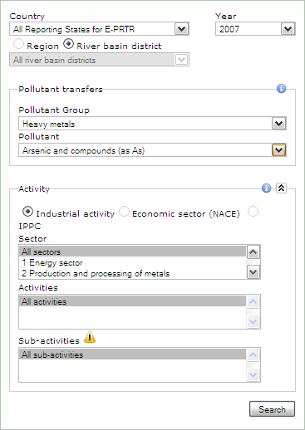

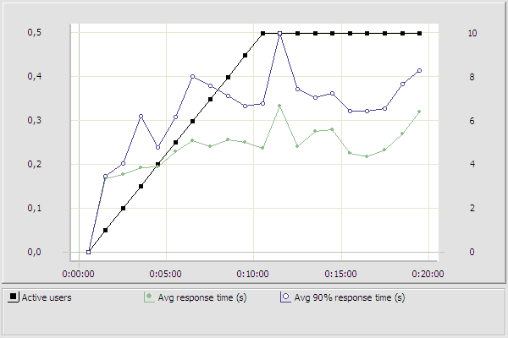

**Response time, sec**

|  |  |  |  |  |  |  |  |  |  |  |  |  |  |  |  |  |  |  |  |  |
| --- | --- | --- | --- | --- | --- | --- | --- | --- | --- | --- | --- | --- | --- | --- | --- | --- | --- | --- | --- | --- |
| Time | 0 | 1 | 2 | 3 | 4 | 5 | 6 | 7 | 8 | 9 | 10 | 10 | 10 | 10 | 10 | 10 | 10 | 10 | 10 | 10 |
| Avg | 0 | 0,17 | 0,18 | 0,19 | 0,2 | 0,23 | 0,25 | 0,24 | 0,26 | 0,25 | 0,24 | 0,33 | 0,24 | 0,28 | 0,28 | 0,22 | 0,22 | 0,23 | 0,27 | 0,32 |
| Avg90 | 0 | 0,17 | 0,2 | 0,31 | 0,24 | 0,31 | 0,4 | 0,38 | 0,36 | 0,33 | 0,34 | 0,5 | 0,37 | 0,35 | 0,36 | 0,32 | 0,32 | 0,33 | 0,38 | 0,41 |
| Max | 0 | 0,18 | 0,22 | 0,97 | 0,33 | 0,56 | 0,92 | 0,9 | 0,6 | 0,38 | 0,36 | 0,73 | 1,02 | 0,38 | 0,38 | 0,38 | 0,66 | 0,4 | 0,71 | 0,54 |

**Waste Transfers**

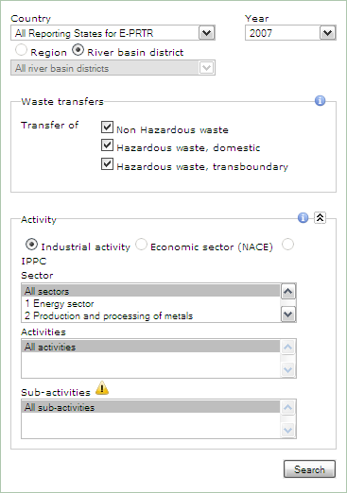

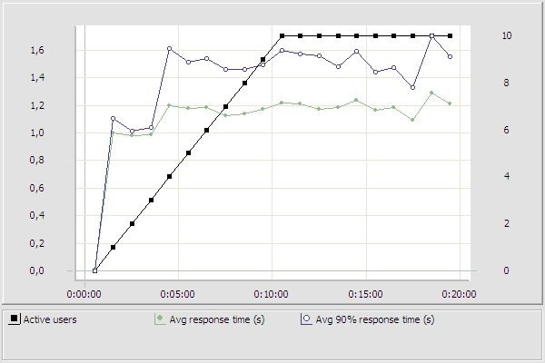

**Response time, sec**

|  |  |  |  |  |  |  |  |  |  |  |  |  |  |  |  |  |  |  |  |  |
| --- | --- | --- | --- | --- | --- | --- | --- | --- | --- | --- | --- | --- | --- | --- | --- | --- | --- | --- | --- | --- |
| Users | 0 | 1 | 2 | 3 | 4 | 5 | 6 | 7 | 8 | 9 | 10 | 10 | 10 | 10 | 10 | 10 | 10 | 10 | 10 | 10 |
| Avg | 0 | 1,0 | 0,98 | 0,98 | 1,2 | 1,18 | 1,19 | 1,12 | 1,14 | 1,17 | 1,22 | 1,21 | 1,17 | 1,18 | 1,24 | 1,17 | 1,18 | 1,09 | 1,29 | 1,21 |
| Avg90 | 0 | 1,1 | 1,01 | 1,04 | 1,61 | 1,52 | 1,54 | 1,46 | 1,46 | 1,49 | 1,6 | 1,57 | 1,56 | 1,48 | 1,59 | 1,44 | 1,47 | 1,33 | 1,7 | 1,56 |
| Max | 0 | 1,47 | 1,06 | 1,17 | 2,09 | 2,08 | 2,02 | 2,09 | 1,99 | 2,31 | 2,8 | 2,01 | 2,56 | 2,3 | 2,59 | 2,08 | 2,02 | 1,95 | 2,59 | 2,59 |